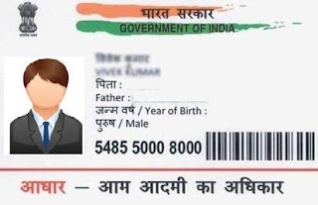



[This Photo](https://aamjanata.com/10-big-problems-with-the-aadhaar-uid-card-project/) by Unknown Author is licensed under [CC BY](https://creativecommons.org/licenses/by/3.0/)



[This Photo](https://allwavingflags.blogspot.com/2018/06/flag-of-india.html) by Unknown Author is licensed under [CC BY](https://creativecommons.org/licenses/by/3.0/)

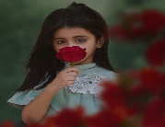 चंचल

Chanchal

जन्म तिथि/ DOB- 21-07 1998

महिला/Female

2065 7889 7320

VID:9158 0415 6507 2897

मेरा आधार , मेरी पहचान